Data regarding students’ perceptions of being observing performing critical skills
Rotation | Date Range | % affirming history taking skills observed and critiqued | % affirming physical exam skills were observed and critiqued
Family Medicine (FCH 742) | 1/1/2018 – 12/31/2018 | 100 | 100
Internal Medicine (MED 742) | 1/1/2018 – 12/31/2018 | 100 | 100
MS4 Sub-I Medicine (MED 827) | 1/1/2018 – 12/31/2018 | 100 | 100
MS4 MICU (MED 833) | 1/1/2018 – 12/31/2018 | 100 | 100
Neurology (NEU 742) | 1/1/2018 – 12/31/2018 | 100 | 100
OBGYN (OBG 742) | 1/1/2018 – 12/31/2018 | 100 | 100
MS4 Sub-I OBGYN (OBG 872) | 1/1/2018 – 12/31/2018 | 100 | 100
Pediatrics (PED 742) | 1/1/2018 – 12/31/2018 | 100 | 100
MS4 Sub-I Peds (PED 827) | 1/1/2018 – 12/31/2018 | 100 | 100
Psychiatry (PSY 742) | 1/1/2018 – 12/31/2018 | 100 | 100
MS4 Sub-I Psych (PSI 827) | 1/1/2018 – 12/31/2018 | 100 | 100
Surgery (SUR 742) | 1/1/2018 – 12/31/2018 | 100 | 100
MS4 Sub-I Surgery (SUR 827) | 1/1/2018 – 12/31/2018 | 100% affirmed receiving useful feedback regarding academic and clinical performance during the clerkship
MS4 SICU | 1/1/2018-12/31/2018 | 100% affirmed receiving useful feedback regarding academic and clinical performance during the clerkship

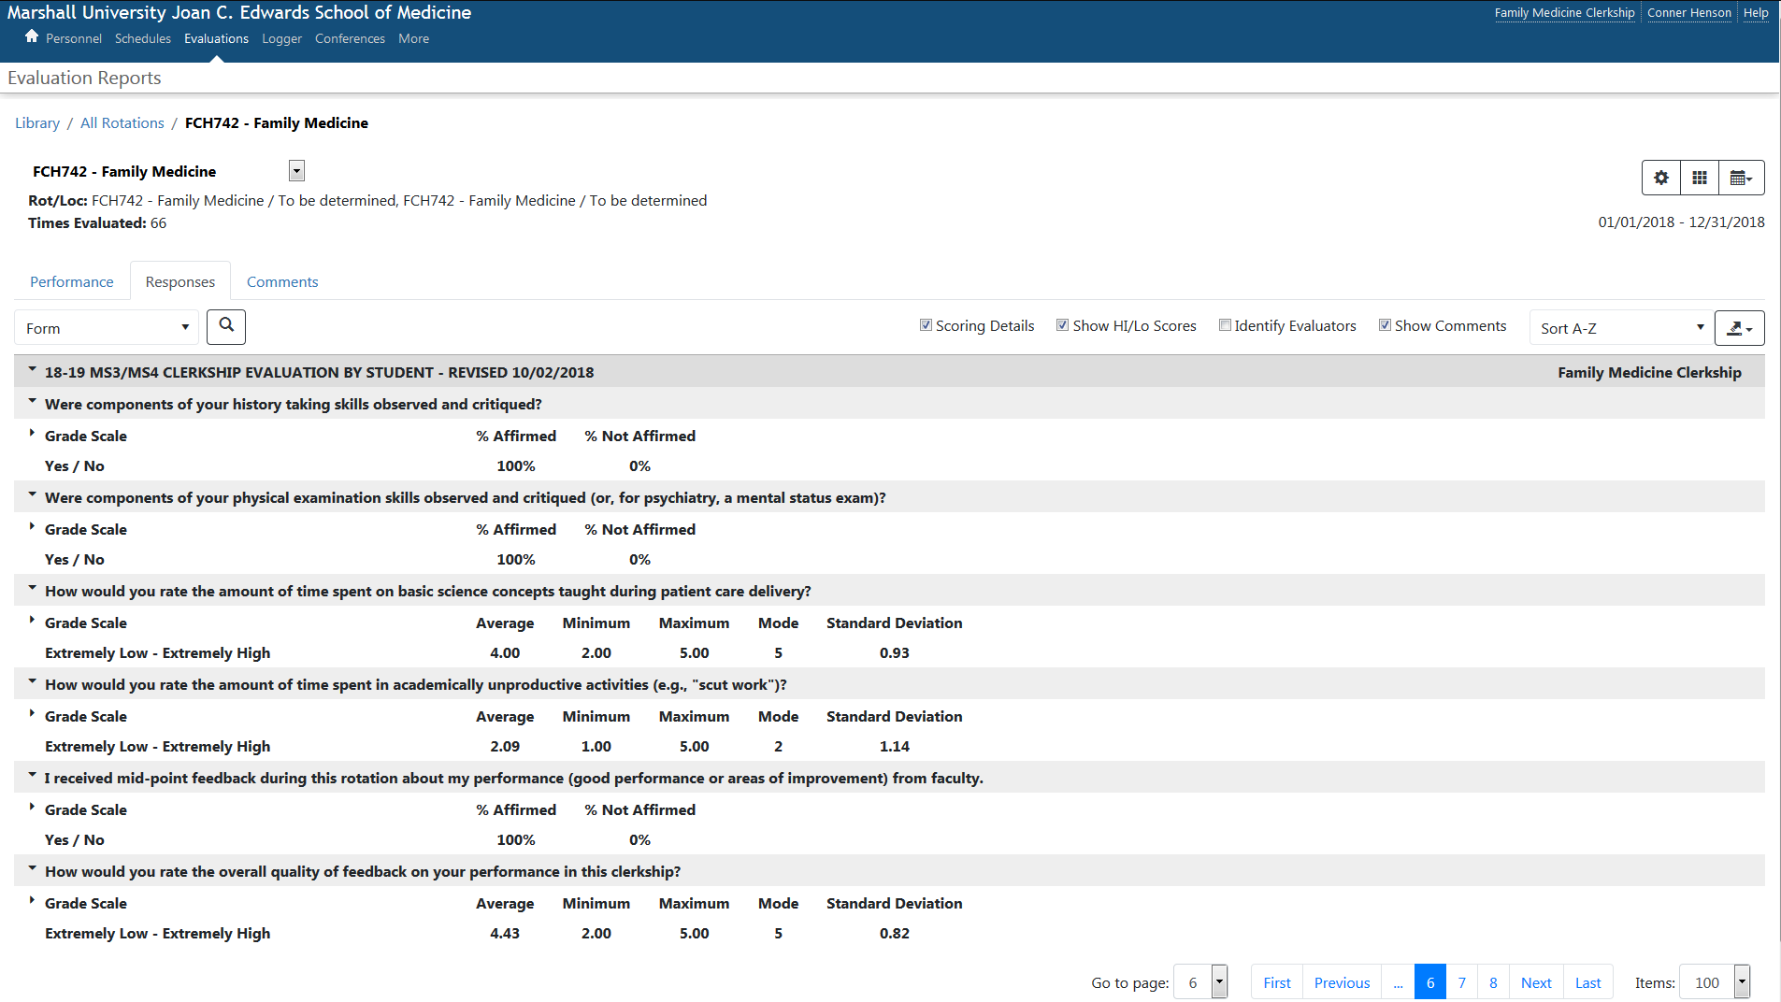
Data was taken from clerkship evaluations in the New Innovations System. An sample clerkship evaluation for Family Medicine (FCH 742) is below.

